Example No 01: Make a calculator to calculate the Area in feet and inches.
Input:
using System;

namespace Home_task_01
{
class Program
{
static void Main(string[] args)
{
//Make a calculator to calculate area in feet and inches
//We have:
// Length = 15 feet, 6 inches
// Breadth = 16 feet, 5 inches
// Formula:
// Area = Length * Breadth
// Where;
// li = Length in inches
// lf = Length in Feet
// bi = Breadth in inches
// bf = Breadth in Feet
// ai = Area in Inches
// af = Area in Feet

int li, lf, bi, bf, ai, af;
li = 6;
lf = 15;
bi = 5;
bf = 16;
ai = li * bi;
af = lf * bf;
if (ai >= 12) { int r = ai / 12;
af = af + r;
int i = ai % 12;
ai = i;
}
Console.WriteLine("The Area is {0} feets and {1} inches", af, ai);

}
}
}
Output:
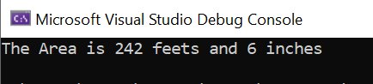
Example No 02: Make an Interest Calculator.
Input:
using System;

namespace Home_Task_02
{
class Program
{
static void Main(string[] args)
{
//Calculate the value of interest by taking principle value from user.
//We have:
// i = interest
// p = Principle value
// r = Rate
// t = Time
//Formula:
// i = (p*t*r)/100
double p, t;
double r, i;
Console.WriteLine("Please enter the Principal amount:");
p = Convert.ToDouble(Console.ReadLine());
Console.WriteLine("For How many years?");
t = Convert.ToDouble(Console.ReadLine());
r = 16.5;
i = p * t * r / 100;
double finalAmount = i + p;
Console.WriteLine("Your ammount after {0} Years will be {1} Rupees.", t, finalAmount);
}
}
}
Output:
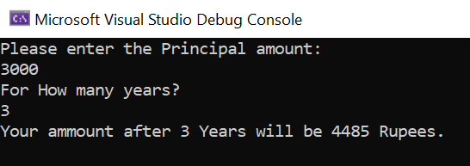

Example No 03: Make a temperature converter that convert Kelvin in Fahrenheit.
Input:
using System;

namespace Home_Task_03
{
class Program
{
static void Main(string[] args)
{
//Convert temperature from Kelvin To Fahrenheit
//We have:
// k = temperature in kelvin
// f = temperature in fahrenheit
// c = temperature in celcius
//Formula:
// f = 9 / 5 * (k - 273) + 32;
// where c = k - 32;

Double k, f, c;
Console.WriteLine("Enter Temperature in Kelvin:");
k = Convert.ToDouble(Console.ReadLine());
c = k - 273;
f = 9/5 * c + 32;
Console.WriteLine("The Temperature in Fahrenheit is=" + f);
}
}
}
Output:
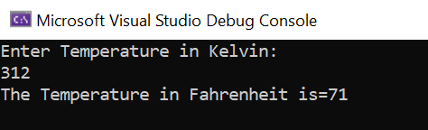

Home Task 01: Calculate distance covered by a body moving with uniform velocity.
Input:
using System;

namespace Home_Task_04
{
class Program
{
static void Main(string[] args)
{
//Calculate the distance covered by a body moving with uniform velocity.
// we have:
// s = Distance
// v = Uniform Velocity
// t = Time
//Formula:
// s = v*t
Double s, v, t;
Console.WriteLine("Enter The Velocity of Vehicle (m/s):");
v = Convert.ToDouble(Console.ReadLine());
Console.WriteLine("Enter the time in seconds:");
t = Convert.ToDouble(Console.ReadLine());
s = v * t;
Console.Write("The Distance Covered by Vehicle is "+s);
Console.Write(" m");
}
}
}
Output;
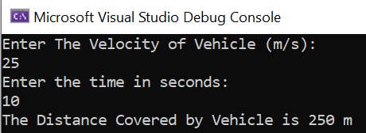

Home Task 02: Calculate the final velocity of a Vehicle by using 1st Equation of Motion.
Input:
using System;

namespace Home_Task_05
{
class Program
{
static void Main(string[] args)
{
Double vf, vi, a, t;
Console.WriteLine("Enter initial Velocity: ");
vi = Convert.ToDouble(Console.ReadLine());
Console.WriteLine("Enter the acceleration: ");
a = Convert.ToDouble(Console.ReadLine());
Console.WriteLine("Enter time in seconds: ");
t = Convert.ToDouble(Console.ReadLine());

vf = vi + a * t;
Console.WriteLine("The final velocity of vehicle after {0} second is {1} m/s", t, vf);
}
}
}
Output:
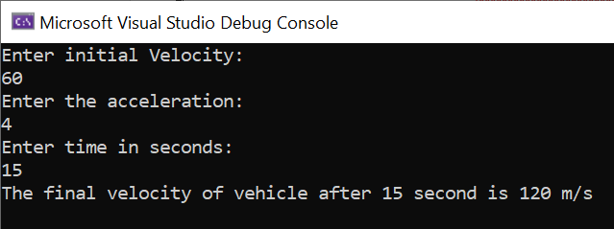
Home Task 03: Calculate distance By using second Equation of motion.
Input:
using System;

namespace Home_Task_05
{
class Program
{
static void Main(string[] args)
{
Double vi, t, a, s;
Console.WriteLine("Enter initial velocity: ");
vi = Convert.ToDouble(Console.ReadLine());
Console.WriteLine("Enter time in seconds: ");
t = Convert.ToDouble(Console.ReadLine());
Console.WriteLine("Enter acceleration: ");
a = Convert.ToDouble(Console.ReadLine());

s = vi * t + 1/2*(a * t * t);
Console.WriteLine("The distamce covered by Vehicle is: " + s);
}
}
}
Output:
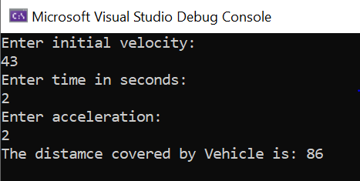

Home Task 04:
Input:
using System;

namespace Home_Task_05
{
class Program
{
static void Main(string[] args)
{
double a, s, vf, vi;
// Console.WriteLine("enter the acceleration");
//a = Convert.ToDouble(Console.ReadLine());
Console.WriteLine("enter the final velocity");
vf = Convert.ToDouble(Console.ReadLine());
Console.WriteLine("enter the initial velocity");
vi = Convert.ToDouble(Console.ReadLine());
Console.WriteLine("enter the Distance: ");
s = Convert.ToDouble(Console.ReadLine());

a = (vf * vf - vi * vi)/2*s;
Console.WriteLine("tHE REQUIRED ACCELERATION IS"+a);

}
}

Output:
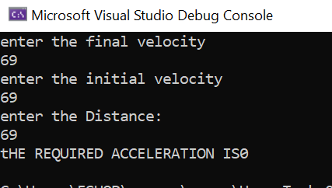

Home Task 05: Make a program to identify whether the number is Even or Odd.
Input:
using System;

namespace Home_Task_08
{
class Program
{
static void Main(string[] args)
{
Console.WriteLine("Enter Number");
int num1 = Convert.ToInt32(Console.ReadLine());
if (num1 % 2 == 0)
{ Console.WriteLine("{0} is Even", num1); }
else { Console.Write("{0} is Odd", num1); }
}
}
}
Output:
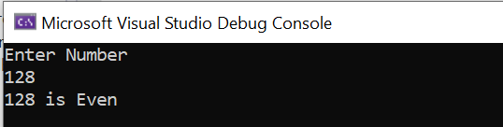
Home Task 06: Make a Program to identify which subject have Highest marks in given subjects.
Input:
using System;

namespace Home_Task_09
{
class Program
{
static void Main(string[] args)
{
//m = Maths
//p = Physics
//c = Chemistry

int m, p, c;
Console.WriteLine("Enter marks in Maths");
m = Convert.ToInt32(Console.ReadLine());
Console.WriteLine("Enter marks in Physics");
p = Convert.ToInt32(Console.ReadLine());
Console.WriteLine("Enter marks in Chemisrty");
c = Convert.ToInt32(Console.ReadLine());
if (m>p)
{ if (m>c)
{ Console.WriteLine("Maths marks are Max"); }
else
{ Console.WriteLine("Chemistry marks are Max"); }
}
else if (c>p)
{ Console.WriteLine("Chemistry marks are Max"); }
else
{ Console.WriteLine("Physics marks are Max"); }
}
}
}
Output:
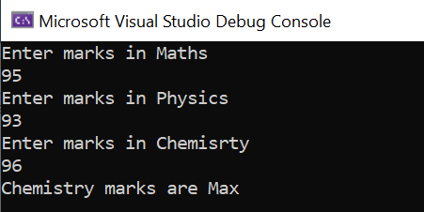
Home task 07: Make a program to identify which side of triangle is Hypotenuse.
Input:
using System;

namespace Home_Task_11
{
class Program
{
static void Main(string[] args)
{
int a, b, c;
Console.WriteLine("Enter length of side 1");
a = Convert.ToInt32(Console.ReadLine());
Console.WriteLine("Enter length of side 2");
b = Convert.ToInt32(Console.ReadLine());
Console.WriteLine("Enter length of side 3");
c = Convert.ToInt32(Console.ReadLine());
if(a>b)
{ if(a>c)
{ Console.WriteLine("Side 1 is the Hypotanuse"); }
else
{ Console.WriteLine("Side 3 is the Hypotanuse"); }
}
else if (c>b)
{ Console.WriteLine("Side 3 is the Hypotanuse"); }
else
{ Console.WriteLine("Side 2 is the Hypotanuse"); }
}
}
}
Output:
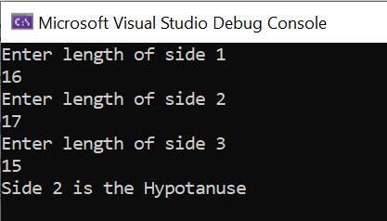
Home Task 08: Make a program To Calculate Total Expenditure of a Year
- Implementation of Program By using For Loop
using System;
namespace Abdullah_Sadiq_CP_Home_Tasks
{
class Program
{
static void Main(string[] args)
{
//tot_exp = total expenditure
int tot_exp = 0;
int exp;
for ( int m = 1; m <=12; m++)
{
Console.WriteLine("Enter Expenditure of Month {0}:", m);
exp = Convert.ToInt32(Console.ReadLine());
tot_exp += exp;
}
Console.WriteLine("Total Expenditure = {0}", tot_exp);
}
}
}

- Implementation of Program By Using While Loop
using System;
namespace Abdullah_Sadiq_CP_Home_Tasks
{
class Program
{
static void Main(string[] args)
{
int tot_exp = 0;
int exp;
int m = 1;
while (m <=12)
{
Console.WriteLine("Enter Expenditure for Month {0}:", m);
exp = Convert.ToInt32(Console.ReadLine());
tot_exp += exp;
m++;
}
Console.WriteLine("Total Expenditure = {0}", tot_exp);
}
}
}

- Implementation of Program By using Do While.
Input:
using System;

namespace Abdullah_Sadiq_CP_Home_Tasks
{
class Program
{
static void Main(string[] args)
{
int exp, tot_exp = 0, m = 1;
do
{
Console.WriteLine("Please Enter Expenditure for Month {0}:", m);
exp = Convert.ToInt32(Console.ReadLine());
tot_exp += exp;
m++;
}
while (m <= 12);
Console.WriteLine("Total Expenditure = {0}", tot_exp);
}
}
}
Output:
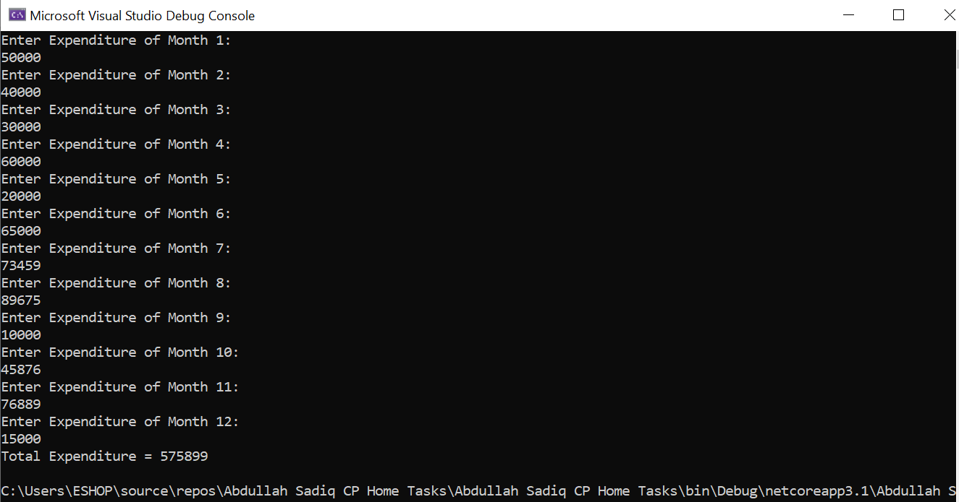
Task No 09: Make a program to maintain a List of people aged above 20.
Input:
using System;

namespace Abdullah_Sadiq_CP_Home_Tasks
{
class Program
{
static void Main(string[] args)
{
int age, n = 0;
char rep;
do
{
Console.WriteLine("Enter your Age:");
age = Convert.ToInt32(Console.ReadLine());
if (age > 20)
{
n++;
}
Console.WriteLine("Is he the Last Student? (press 'y' for Yes, 'n' for No)");
rep = Convert.ToChar(Console.ReadLine());
}
while (rep == 'n' || rep == 'N');
Console.Write("The No of student above Age 20 is = ");
Console.WriteLine(n);
}
}
}
Output:
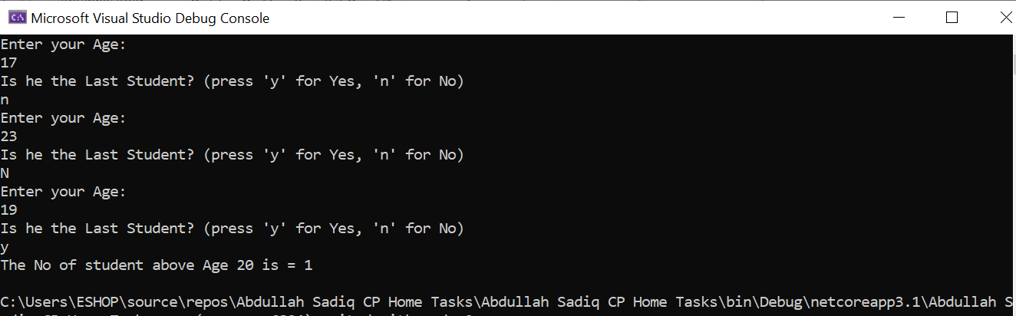
Task No 09: Make a program to count no of Odd and Even Number accepted.
Input:
using System;

namespace Abdullah_Sadiq_CP_Home_Tasks
{
class Program
{
static void Main(string[] args)
{
//e = even
//o = odd
int e = 0, o = 0, num;
for (int cnt = 0; cnt < 5; cnt++)
{
Console.WriteLine("Enter a Number:");
num = Convert.ToInt32(Console.ReadLine());
if (num % 2 ==0)
{
e++;
}
else
{
o++;
}
}
Console.WriteLine("The total Odd Numbers are {0}", o);
Console.WriteLine("The total Even Numbers are {0}", e);
}
}
}
Output:
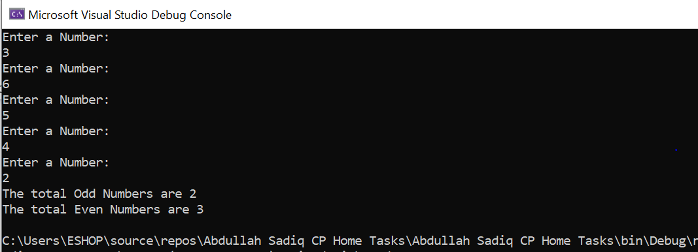
Task No 10:
Input:
using System;

namespace Abdullah_Sadiq_CP_Home_Tasks
{
class Program
{
static void Main(string[] args)
{
double bill, dis, payment;
Console.WriteLine("Enter Billing Amount (in Rs):");
bill = Convert.ToDouble(Console.ReadLine());
if (bill >100)
{
dis = bill * 0.1;
}
else
{
dis = 0;
}
payment = bill - dis;
Console.WriteLine("The Ammount to pay is {0} With discount of {1} Rs", payment, dis);
}
}
}
Output:
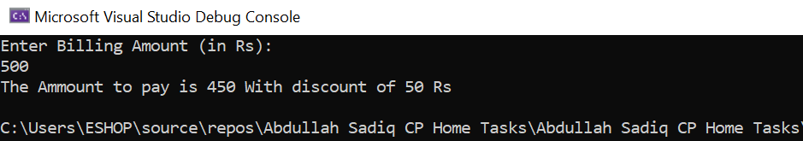
Task No 11: Make a Program to Check whether the citizen is Valid for voting or not.
Input:
using System;

namespace Abdullah_Sadiq_CP_Home_Tasks
{
class Program
{
static void Main(string[] args)
{
string nationality, nic;
int age;
Console.WriteLine("Verify! Are You Eligible For Voting?");
Console.WriteLine("\nPlease Enter your Nationality (Press 'P' for Pakistani, 'O' for Other):");
nationality = Console.ReadLine();
if (nationality.Equals ("P") || nationality.Equals("p"))
{
Console.WriteLine("Enter your Age:");
age = Convert.ToInt32(Console.ReadLine());
if (age >=18)
{
Console.WriteLine("Are you NIC Holder? (Press 'Y' for Yes, 'N' for No):");
nic = Console.ReadLine();
if (nic.Equals ("Y") || nic.Equals("y"))
{
Console.WriteLine("You are a Valid Voter.");
}
else
{
Console.WriteLine("Please Apply for Nic First !");
}
}
else
{
Console.WriteLine("You are not Eligible Since you are Under 18!");
}
}
else
{
Console.WriteLine("Sorry! This Facility is Only available for Pakistani Citezens.");
}
}
}
}
Output:
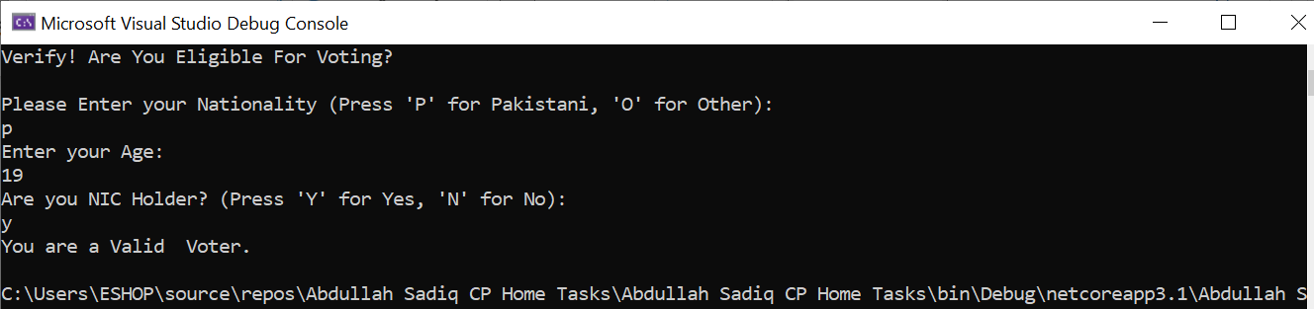
Task No 12:
Input:

Output:

Task No 13:
Input:
Output:

Task No 14:
Input:
Output:

Task No 15:
Input:
Output:

Task No 16:
Input:
Output:

Task No 17:
Input:
Output:

